**Appendix A**

**Intelligent Medical Diagnostic System**

**(Dr. JEBT)**

**User manual**

**How to use the Dr. JEBT system**

Dr. JEBT intelligent diagnostic tool will be a web-based application which will be used by medical practitioners to diagnose patients in a timely manner.

**Installation steps to ensure that the system runs as intended**

1. MySQL server should also be running with the patient and practitioner’s database database present.
2. This Web application should also be deployed on the Apache Server such that it can be accessed using a browser
3. **Web Application**

The major purpose for the web application is to help the medical personnel in management of some of the system functions such as capturing patient details, capture the signs , symptoms and condition of the patient, approval/rejection of appointments, performing prognosis and viewing statistics on different information.

Other users can however also use the platform but for a limited range of functions such as making/viewing their appointments as well as getting more information about Diabetes mellitus.

This web application has the following pages:

* Sign in or Sign up (for new users)
* Make Appointment
* Register patient
* Treatment and Management

1. **Sign in or (Sign Up for new users)**

This is the landing page for the web application and it displays a login for a user to sign in to access the system. For new users, they are required to sign up by creating an account in the system to access the system.

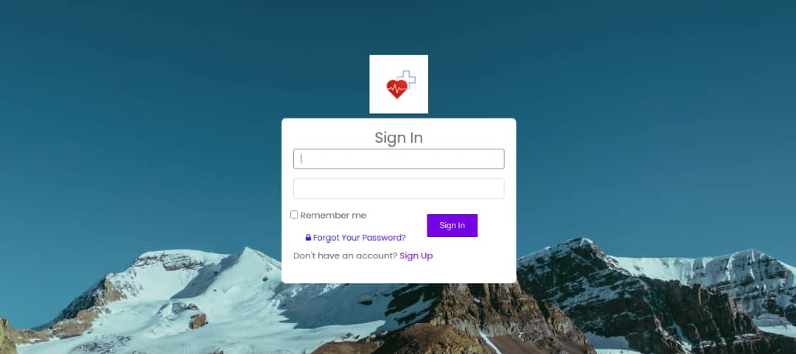

1. **Register Patient**

This module enables a medical personnel to register a patient by capturing his/her details.

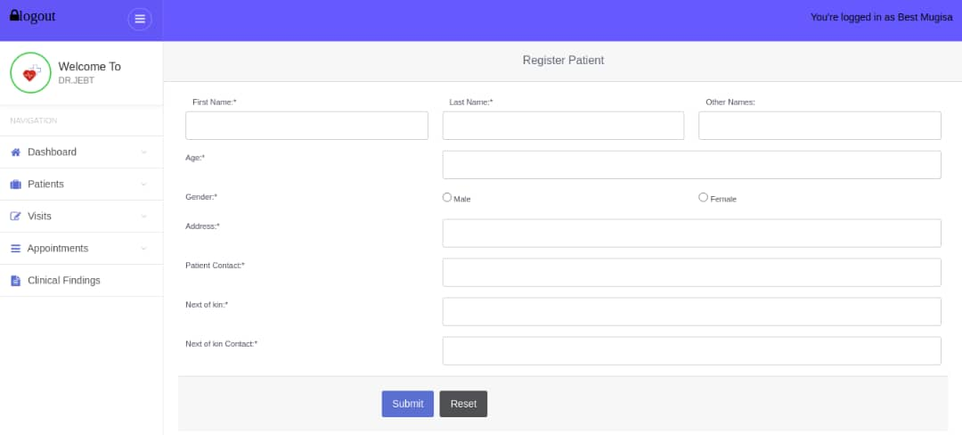

1. **Make Appointment**

This module helps a patient to schedule an appointment with a doctor for diabetes diagnosis.

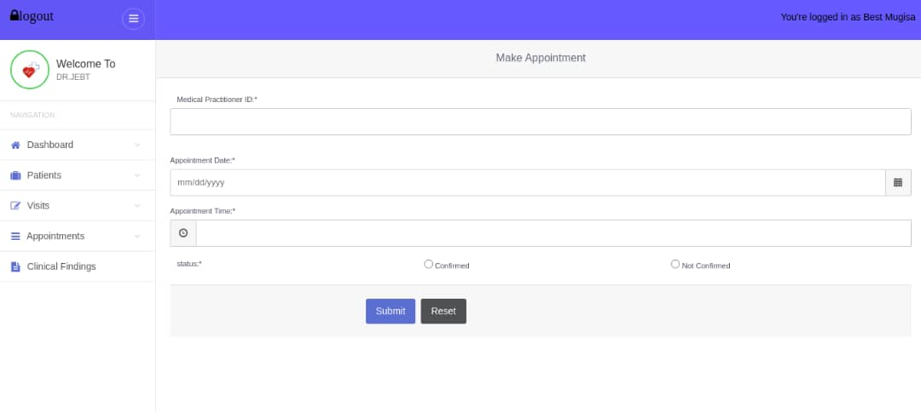

1. **Treatment and Management**

This module gives some information about Diabetes mellitus, effects of diabetes, some treatment and management for diabetes.

